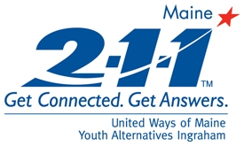 | 2-1-1 Maine: Top 20 Call Categories  All Counties  Reporting Period: August 2009  Total Number of Calls: 5256
Report Date: 09/15/2009

Utilities Assistance | 684
Housing/Shelter | 442
Mental Health Services | 387
Basic Needs - Food | 243
Financial Assistance - Temporary Aid | 239
Heating Assistance | 205
Substance Abuse Services | 204
Legal Services | 180
Health Care | 169
Transportation | 158
Financial Assistance - Rent | 154
Government Agency - DHHS | 126
Law Enforcement Services | 120
Health Insurance | 103
Education/Training | 86
Dental Care | 84
Basic Needs - Clothing | 84
Domestic Violence Services | 79
Income Support - SSI/SSDI | 72
Advocacy | 64

