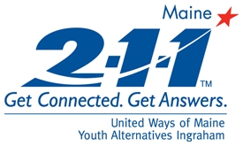 | 2-1-1 Maine: Top 20 Call Categories  All Counties  Reporting Period: October 2009  Total Number of Calls: 6428
Report Date: 11/13/2009

Utilities Assistance | 692
Heating Assistance | 602
Mental Health Services | 407
Housing/Shelter | 373
Seasonal Flu Information | 308
Basic Needs - Food | 287
Financial Assistance - Temporary Aid | 262
Substance Abuse Services | 240
Health Care | 222
Legal Services | 211
Financial Assistance - Rent | 184
H1N1 Virus Information | 181
Transportation | 162
Government Agency - DHHS | 143
Health Insurance | 114
Municipal Services | 103
Law Enforcement Services | 101
Dental Care | 95
Education/Training | 90
Basic Needs - Clothing | 79

