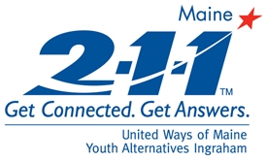 | 2-1-1 Maine: Top 20 Call Categories  All Counties  Reporting Period: September 2009  Total Number of Calls: 5696
Report Date: 10/16/2009

Utilities Assistance | 672
Mental Health Services | 432
Housing/Shelter | 403
Heating Assistance | 375
Basic Needs - Food | 255
Financial Assistance - Temporary Aid | 248
Health Care | 216
Legal Services | 197
Financial Assistance - Rent | 178
Substance Abuse Services | 165
Government Agency - DHHS | 165
Transportation | 163
Dental Care | 112
Education/Training | 109
Financial Assistance - Home Maintenance | 98
Health Insurance | 85
Support Group Information | 81
Income Support - SSI/SSDI | 79
Law Enforcement Services | 77
Municipal Services | 75

