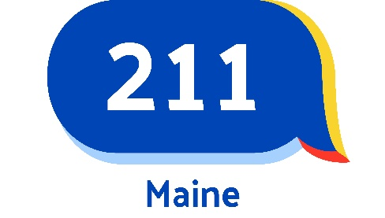
Agency and Program Profile Form
Please use this form to submit a new agency or program profile for approval or update.
Unless otherwise noted, all fields must be included.
Please submit forms to resources@211maine.org.

Organization Information

Agency or Program Name (required):

Alternate Name / Alias(es) / Acronym (required, if applicable):

Description of Agency or Program (required):
Describe your services.

Additional services available to individuals already receiving services through your agency or location (optional):
i.e., transportation or babysitting available to clients of a residential program.

Eligibility (required if applicable):
Describe eligibility requirements for services or programs offered, if applicable. If providing to specific ages, please clarify whether through a specific age or to a specific age i.e. 8 years of age to 19 years of age (this implies that the program will only be available until the client reaches 19 years of age but not after the 19th birthday). Please also specify if the program is only available to a specific gender and/or community, such as veterans.

Languages Offered (required):
If interpreter services are offered, please note this as well.

Fees and Payment (required fields, check all that apply)
Program Fees: | Methods of Payment:
- ☐ No Cost  - ☐ Low Cost  - ☐ Fixed Cost  - ☐ Sliding Fee  - ☐ Vary  - ☐ Donation | - ☐ MaineCare  - ☐ Medicare  - ☐ Cash  - ☐ Credit Cards  - ☐ Debit Cards  - ☐ Private Insurance  - ☐ Check  - ☐ Money Order  - ☐ Electronic Payment
Financial assistance or scholarships available? | Uninsured individuals accepted?
- ☐ Yes  - ☐ No | - ☐ Yes  - ☐ No

Application Process (required if applicable):
Describe the standard intake procedures required to obtain services.

Documents Required (required if applicable):
Describe any documents required for application and services.

Coverage Area Served (required):
Please include counties, cities, and/or towns for which your organization provides services. If your organization provides services to different areas based on locations, please note this here. For example: a food pantry that serves a specific town, or clinics that serve different, respective counties.

Main Addresses
City, town, and zip are required for all database profiles, even if they are online-only.

Physical Address (required fields)
Head office or main facility.
Address (street):
Address 2 (optional):
City:
State:
Zip Code:
Address Confidential? | - ☐ Yes
Hours of Operation (required; ex.: Mon-Fri, 8a-5p).

Mailing Address (required fields, IF different from above)
Address (street):
Address 2 (optional):
City:
State:
Zip Code:
Address Confidential? | - ☐ Yes

Contact Information

Phone Numbers
Main Phone (Business Line, required): |  | - ☐ Private Number
Toll Free (optional): |  | - ☐ Private Number
Hotline (optional): |  | - ☐ Private Number
After Hours (optional): |  | - ☐ Private Number
Fax (optional): |  | - ☐ Private Number
Emergency Phone (optional): |  | - ☐ Private Number
Other Phone 1 (optional):  Please note what this line is. |  | - ☐ Private Number
Other Phone 2 (optional):  Please note what this line is. |  | - ☐ Private Number

Online Details (required if available)
Main Email Address:
Website:

Main Contact Person (required)
Contact Name:
Title (role at organization):
Phone:
Email:
Information Confidential? | - ☐ Yes

Agency Director / Senior Administrator (required)
Name:
Title (role at organization):
Phone:
Email:
Information Confidential? | - ☐ Yes

Legal Status (required)
- ☐ Faith-based
- ☐ For Profit
- ☐ Government
- ☐ Nonprofit - Incorporated
- ☐ Nonprofit - Unincorporated

Person Completing This Form (required)
Please enter your information below - for verification purposes only, this information will not be shared with callers.
Name:
Title (role at organization):
Phone:
Email:
Date Form Completed:

